European Research Council Synergy Grant 2019 MEET awarded

An ERC (European Research Council) Synergy grant of €12.8 million over six years (2020-2026) has been awarded to John Valley (University of Wisconsin-Madison, USA),
Alexander Sobolev (Université Grenoble-Alpes, France), and Stephen Sobolev (GFZ-Potsdam, Germany) to study the evolution of Earth’s chemical composition and the underlying physical processes from 4.4 billion years ago to present in a project entitled “Monitoring Earth Evolution through Time” (MEET).
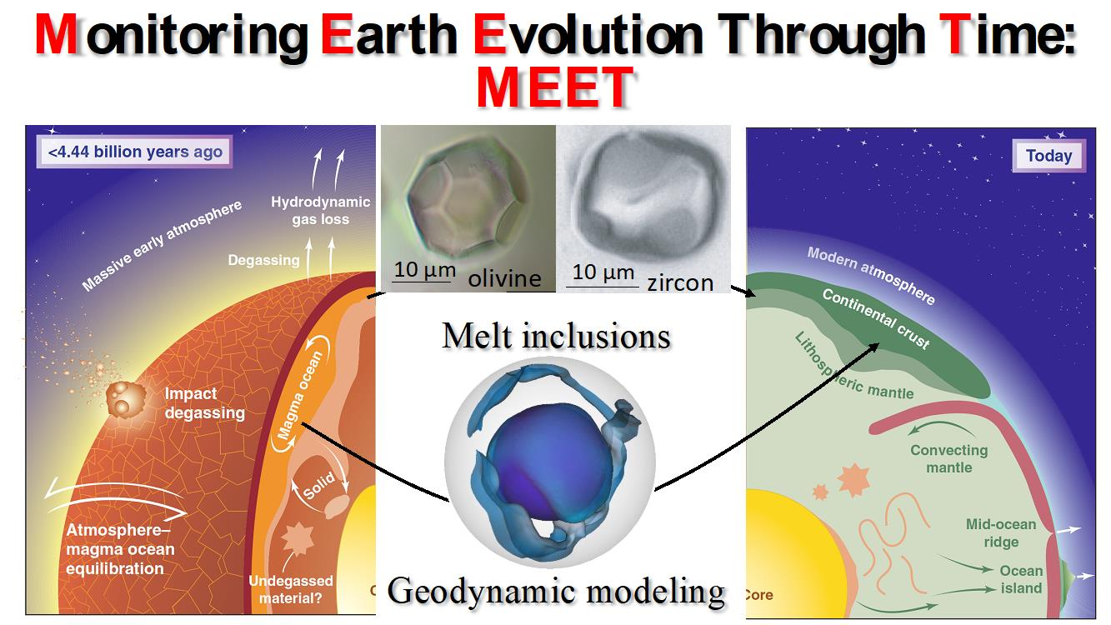
The ERC Synergy Grant Project MEET combines chemical and physical methods to study evolution of Earth from the Hadean to Recent.

The Earth is a unique planet. No other body in our Solar System has all 3 phases of water on its surface: solid, liquid and vapor. And no other planet has plate tectonics. Why is this? And what is the relation of plate tectonics to water? To answer these and other questions, it is necessary to understand the movement of mass and energy between Earth’s deep mantle, surface and back again - which geologists call recycling. Recycling has been responsible for dramatic changes of the Earth’s crust and mantle over 4500 million years since the planet’s formation, for the continental land-masses above sea level and for the resources that people are using now. The evolution of Earth has profound implications for questions in other disciplines such as the origin of life and the conditions on exoplanets. In spite of the obvious importance, the evolution of Earth is still poorly understood.

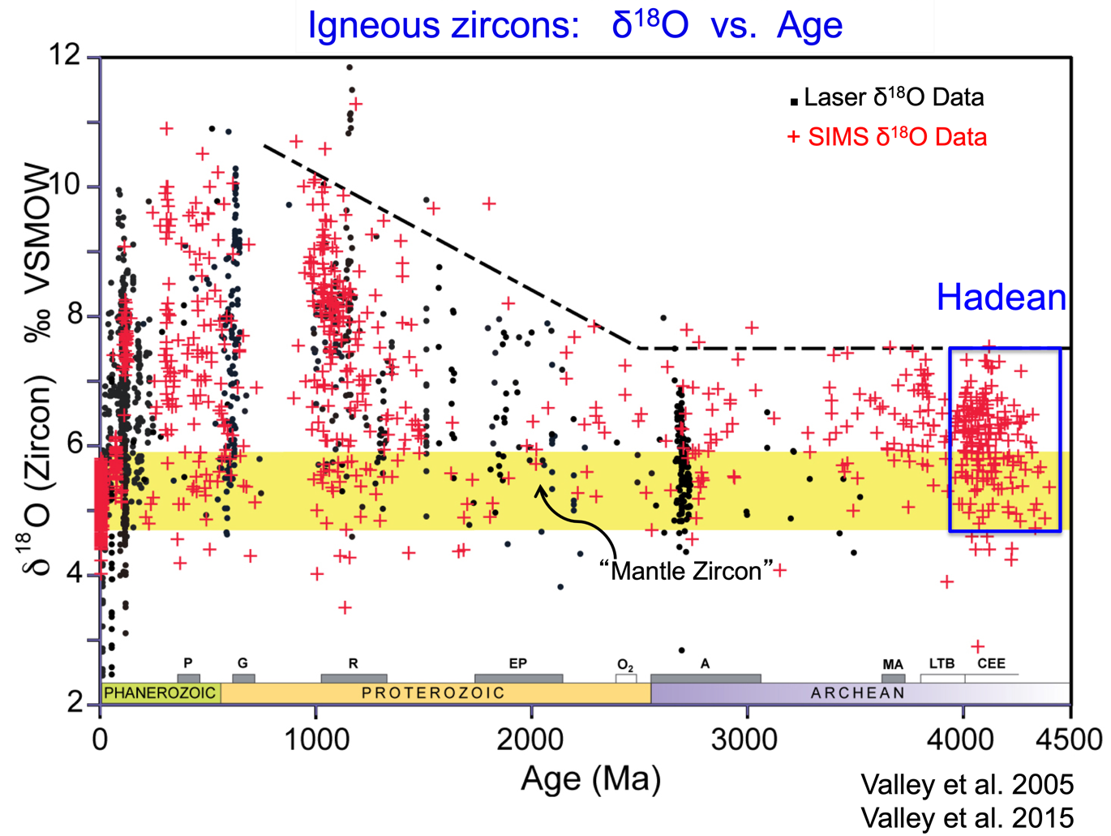
This project will investigate two main questions: How has Earth’s chemical composition evolved over time? And what physical processes are responsible for these changes? Previous attempts to understand the early Earth have been stymied because rocks that are archives from this time are either destroyed or altered so that the original chemical information is gone. However, there is a unique possibility to retrieve the chemical tracers most sensitive to changes of Earth’s mantle and crust. This information is preserved as melt inclusions armored within crystals of the refractory minerals, olivine and zircon. These are tiny drops of melt that were trapped when the mineral crystallized. They typically measure less than 15 microns and weigh just a few nanograms. The Madison and Grenoble teams will examine millions of grains and study thousands of melt inclusions in olivine and zircon for major, trace and volatile elements and isotopes. Microanalytical equipment for in-situ analysis of melt inclusions and host minerals will include SIMS, EPMA, LA-ICPMS, electron microscope and laser-Raman. In collaboration with geodynamic modeling by the Potsdam team, this will provide new information on the recycling of chemical elements in the Earth and on evolution of its crust from 4.4 billion years ago to the present day.
The oxygen isotope ratios of unaltered igneous zircons record a steady-state throughout the Archean and Hadean and profound changes at ~2500 Ma. Mildly elevated values (>6‰) indicate recycling of surface materials altered at low temperatures by liquid water (Valley et al. 2002). Analysis of melt inclusions within selected zircons will, for the first time, determine volatile content of parent magmas and the major and trace element chemistry of Hadean magmas.

References:
Cavosie AJ, Valley JW, Wilde SA (2019) The Oldest Terrestrial Mineral Record: Thirty Years of Research on Hadean Zircon From Jack Hills, Western Australia. In: Earth’s Oldest Rocks. MJ Van Kranendonk (ed.), Elsevier, p 255-278. doi.org/10.1016/B978-0-444-63901-1.00012-5
10.1016/B978-0-444-63901-1.00012-5 - View PDF
Valley JW and Kita NT (2009) In situ Oxygen Isotope Geochemistry by Ion Microprobe, In: Fayek M. (ed) MAC Short Course: Secondary Ion Mass Spectrometry in the Earth Sciences, v 41, 19-63.
Valley, JW, Peck, WH, King, EM, Wilde, SA (2002) A cool early Earth. Geology 30: 351-354.
Valley JW, Lackey JS, Cavosie AJ, Clechenko CC, Spicuzza MJ, Basei MAS, Bindeman IN, Ferreira VP, Sial AN, King EM, Peck WH, Sinha AK, Wei CS (2005) 4.4 billion years of crustal maturation: Oxygen isotopes in magmatic zircon. Contr. Mineral. Petrol. 150:561-580.
Valley JW, Reinhard DA, Cavosie AJ, Ushikubo T, Lawrence DF, Larson DJ, Kelly TF, Snoeyenbos D, Strickland A (2015) Nano- and Micro-geochronology in Hadean and Archean Zircons by Atom-Probe Tomography and SIMS: New Tools for Old Minerals. Am. Mineral, 100: 1355-1377. doi.org/10.2138/am-2014-5134.
10.2138/am-2015-5134 - View PDF

Links:
University of Wisconsin-Madison

John Valley
http://geoscience.wisc.edu/geoscience/people/faculty/john-valley/

WiscSIMS
http://www.geology.wisc.edu/~wiscsims/

Université Grenoble-Alpes
https://edu.univ-grenoble-alpes.fr/news/the-earth-sciences-meet-project-awarded-the-erc-synergy-grant-2019-817113.htm

GFZ-Potsdam
https://www.gfz-potsdam.de/en/section/geodynamic-modeling/overview/

